Anytime
Continuous Glucose Monitoring Systems

Manage your glucose Anytime, Anywhere!
The Yuwell Anytime CGM system features a lightweight, comfortable sensor and a fully rechargeable transmitter that work together to provide continuous, real-time glucose monitoring. The sensor is worn on the back of the upper arm or abdomen for up to 14 days, while the reusable transmitter wirelessly sends glucose data to your smartphone. With a lifespan of up to 2 years, the rechargeable transmitter offers a reliable, convenient, and sustainable solution for everyday glucose management.

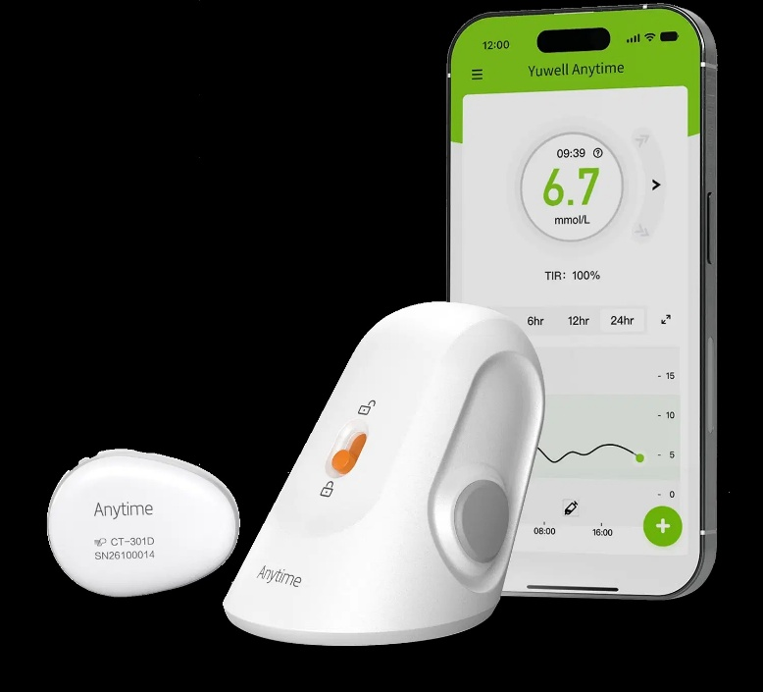
Top Glucose Monitoring Systems in Europe 2026
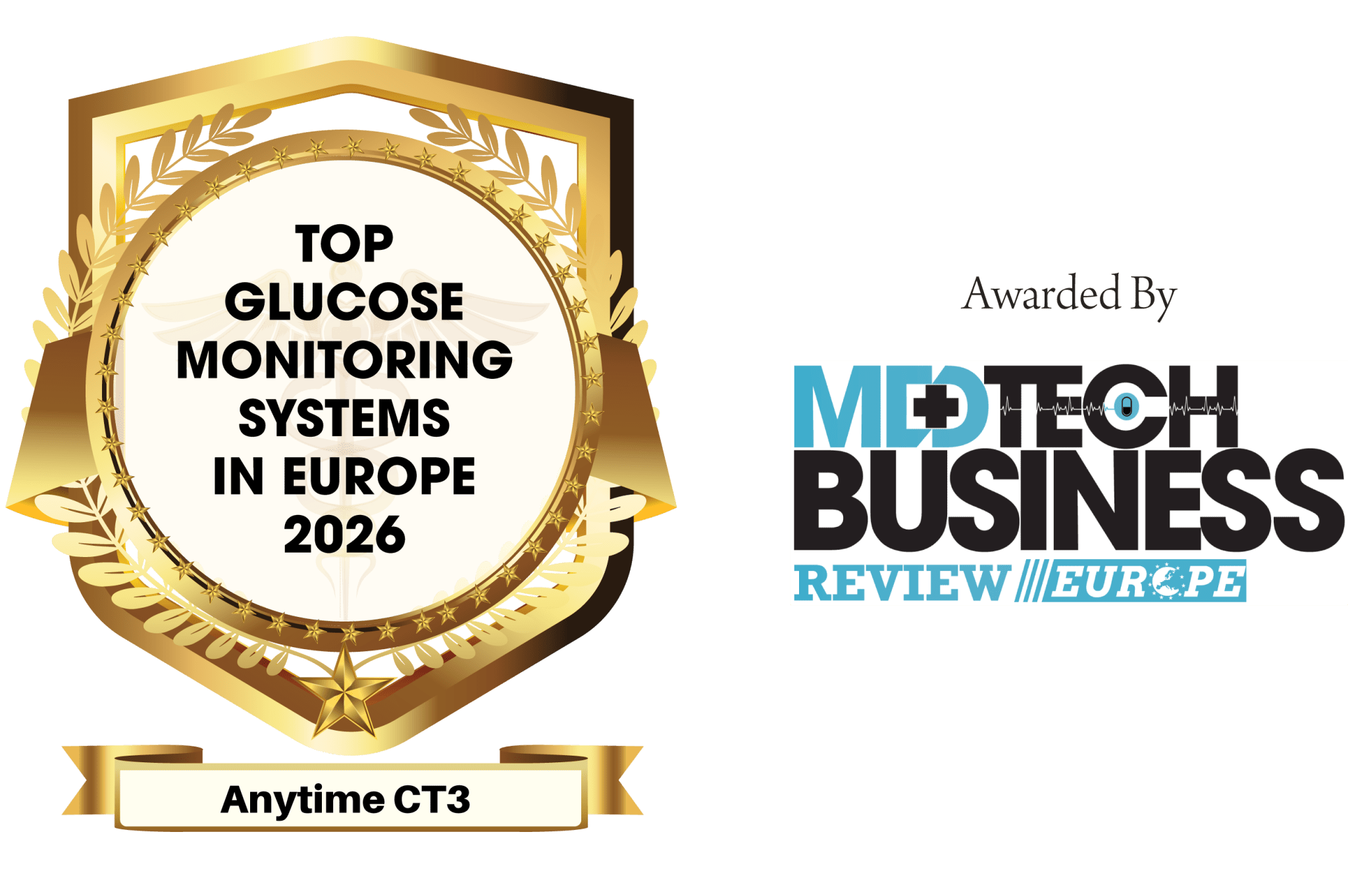

Anytime CT3 has been voted the Best CGM in Europe by European MedTech Business Magazine - recognition that reflects a genuinely historic milestone in the fight against one of the UK and Europe's most urgent preventable health crises.

Anytime App
Better management with the Yuwell Anytime App
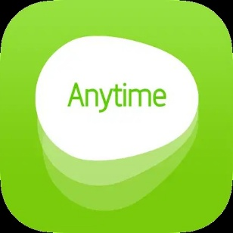

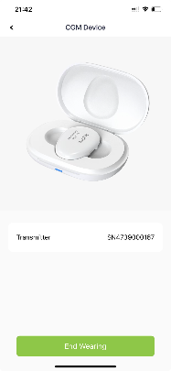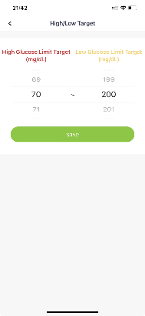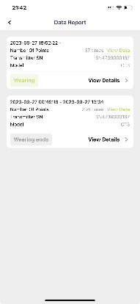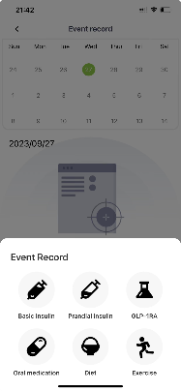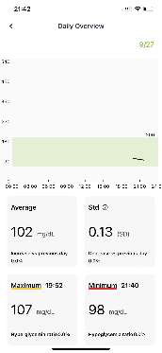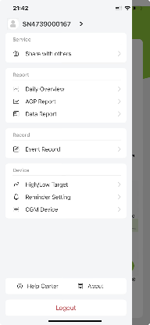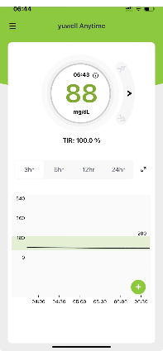

Introducing a world-first rechargeable CGM transmitter.

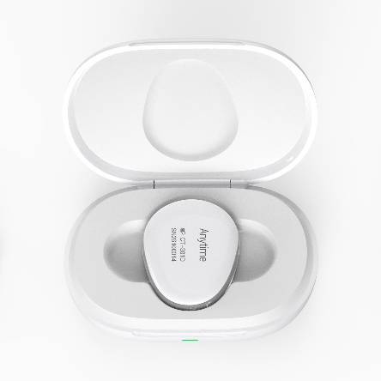
With readings every three minutes and unlimited data storage, this cutting-edge device uses Bluetooth technology to sync seamlessly with your phone or tablet. The Anytime CT-3 CGM transmitter lasts an impressive two years, reducing both costs and environmental waste. Its state-of-the-art ergonomic design ensures user-friendly operation, while superior sterile packaging enhances safety. Best of all, you only need to replace the sensor every two weeks—keeping the transmitter for long-term use!

https://www.yuwellanytime.co.uk/

